**PLANNING PROPOSAL**

**Gateway Version**

**Reclassification of Community Land to Operational Land at**

**2C T C Frith Avenue BOOLAROO**

**(Lot 2 DP 1183441)**

**Amendment to**

**Lake Macquarie Local Environmental Plan 2014**

**Prepared by**

**LAKE MACQUARIE CITY COUNCIL**



**CONTENTS**

**INTRODUCTION**

**PART 1** Objective of the Planning Proposal

**PART 2** Explanation of Provisions

**PART 3** Justification of the Provisions

*Section A: Need for the Planning Proposal*

*Section B: Relationship to Strategic Planning Framework*

*Section C: Environmental, Social and Economic Impact*

*Section D: State and Commonwealth Interests*

**PART 4** Maps

**PART 5** Community Consultation

**PART 6** Project Timeline

**APPENDIX:**

***Annex A*** **Maps**

***Annex B*** **SEPP Assessment**

***Annex C* Ministerial Directions Assessment**

***Annex D* Council Resolutions**

**Planning Proposal**

**2C T C Frith Avenue BOOLAROO**

**Draft Amendment F2014/00781 to Lake Macquarie Local Environmental Plan 2014**

**Gateway Version**

|  |  |
| --- | --- |
| **Local Government Area:** | Lake Macquarie City Council (LMCC) |
| **Name of Draft LEP:** | Draft Amendment F2014/00781 to Lake Macquarie Local Environment Plan 2014 |
| **Subject Land:** | 2C T C Frith Avenue BOOLAROO  Lot 2 DP 1182441  *(Refer to Appendix 1 for further details)* |
| **Land Owners:** | Lake Macquarie City Council (LMCC) |
| **Applicant:** | Lake Macquarie City Council (LMCC) |
| **Department of Planning and Environment reference number:** |  |
| **Council Reference Number:** | F2014/01084 |
| **Date:** | February 2015 |
| **Author:** | Joanne Marshall – Statutory Property Officer |

**Part 1 – OBJECTIVES OR INTENDED OUTCOMES**

The Planning Proposal seeks to amend Schedule 4 of the Lake Macquarie Local Environmental Plan 2014 as follows:

1. Reclassification of part of Lot 2 DP 1183441 (2C T C Frith Avenue Boolaroo) from Community Land to Operational Land for the purpose of a boundary adjustment; and
2. Classification of part of Lot 1 DP 1183441 (1A Main Road Boolaroo) to Community Land for the purpose of a boundary adjustment.

**Part 2 – EXPLANATION OF PROVISIONS**

The provisions in this planning proposal will amend LMLEP 2014 as outlined below:

1. To amend Schedule 4 Part 1 to reclassify part of Lot 2 DP 1183441 (2C T C Frith Avenue Boolaroo) from Community Land to Operational Land for the purpose of a boundary adjustment; and
2. To include in Schedule 4 Part 3 classification of part of Lot 1 DP 1183441 (1A Main Road Boolaroo) to Community Land for the purpose of a boundary adjustment.

**Part 3 – Justification for the Provisions**

**Section A - Need for the Planning Proposal**

1. *Is the planning proposal a result of any strategic study or report?*

The Planning Proposal has not been prepared following any outcomes of a study or report relevant to the subject property. The proposal involves a boundary adjustment which is considered minor in nature and accordingly no strategic study or report has been prepared.

The boundary adjustment would enable the Developer to rationalise the road configuration enabling the road and housing lot, in exchange Council would receive additional land along the T C Frith Avenue frontage for incorporation into the Drainage Reserve.  The land was originally dedicated to Council by the applicant at no cost to Council, and was classified as Community at the time of dedication in March 2013 as it was intended to be used as a drainage reserve. This use still remains with the proposed boundary realignment. In order to allow the development to continue in its current form, that part of the drainage reserve to be exchanged needs to be reclassified as Operational Land.

1. *Is the planning proposal the best means of achieving the objectives or intended outcomes, or is there a better way?*

The proposed Planning Proposal amendment is considered the best means of achieving the intended outcome for this property. The land was originally dedicated to Council by the applicant at no cost to Council, and was classified as Community at the time of dedication in March 2013 as it was intended to be used as a drainage reserve.

Investigations reveal that the land **was not** dedicated to Council in lieu of section 94 contributions and therefore reclassification by way of LEP amendment, pursuant to the provisions of the Environmental Planning and Assessment Act 1979, is the only action available to achieve the desired outcomes.

1. *(a) If the provisions of the planning proposal include the extinguishment of any interests in the land, what are the reasons why the interests are proposed to be extinguished.*

The subject land known as 2C T C Frith Avenue BOOLAROO (Lot 2 DP 1182441) has been dedicated to Council as a drainage reserve. Accordingly, Council does not seek to remove a Public Reserve Notation or any other interests pursuant to section 30 of the Local Government Act 1993:

*3. (b) The concurrence of the landowner, where the land is not owned by the relevant planning authority.*

Pursuant to section 28 of the Local Government Act 1993, Council may not forward a Planning Proposal which includes a proposal to classify or reclassify public land, without the approval of the owner of that land.

As the proposal involves a land swap, Lake Macquarie Council is the landowner for part of the site to be reclassified (from Community to Operational land) and Bunderra Holdings Pty Ltd are the owners of part of the land to be transferred to Council and to be classified Community Land. Their concurrence as landowners is attached as Annex E.

**Section B – Relationship to Strategic Planning Framework**

1. *Is the planning proposal consistent with the objectives and actions contained within the applicable regional or sub-regional strategy (including exhibited draft strategies)?*

*Lower Hunter Regional Strategy*

The proposed reclassifications and rezoning are consistent with the Lower Hunter Regional Strategy (LHRS), which has a focus on encouraging residential development and increasing housing choice.

The strategy specifically identifies Glendale as an emerging Major Regional Centre. The subject land is at Boolaroo which is on the southern edge of the Glendale growth area, and accordingly, the adjoining subdivision for residential housing supports the strategy.

The proposal is not contrary to the provisions of the Lower Hunter Conservation Plan.

1. *Is the planning proposal consistent with the local council’s Community Strategic Plan, or other local strategic plan?*

*Lifestyle 2030 Strategy*

Lifestyle 2030 (LS2030) provides the long-term direction for the overall development of the city and describes Council’s high level policies for managing private and public development within Lake Macquarie.

The proposal is consistent with the strategic plan maps in the LS2030.

As stated earlier in this report, the land situated at Boolaroo is on the southern edge of Glendale which is identified as a Regional growth centre for the area. The intended future use of the site to promote residential development is consistent with the objectives of the strategy.

The site is not identified in the Green System map as having any significant environmental features.

1. *Is the planning proposal consistent with applicable state environmental planning policies (SEPPs)?*

An assessment of the proposal against the relevant State Environmental Planning Policies (SEPPs) is provided within *Appendix B*.

1. *Is the planning proposal consistent with applicable Ministerial Directions (s.117 directions)?*

An assessment of the proposal against the Section 117 Ministerial Directions is provided within *Appendix C*.

**Section C – Environmental, Social and Economic Impact**

1. *Is there any likelihood that critical habitat or threatened species, populations or ecological communities, or their habitats, will be adversely affected as a result of the proposal?*

The land proposed for reclassification has not been identified as containing critical habitat or threatened species, populations or ecological communities, or their habitats.

1. *Are there any other likely environmental effects as a result of the planning proposal and how are they proposed to be managed?*

The site and surrounding land has previously been identified as significantly contaminated land and remediation works have taken place. A Site Audit Statement has now been issued by the NSW Environment Protection Authority stating that the land is now suitable for residential use.

Due to the remediation works the land is clear of all vegetation and ground cover. Lot 2 DP 1183441 (2C T C Frith Avenue Boolaroo) contains a drainage basin which currently contains water.

Due to the small-scale nature of the proposed reclassification, Council officers consider it unnecessary to prepare an environmental study under section 57 of the EP&A Act 1979.

1. *How has the planning proposal adequately addressed any social and economic effects?*

The proposed reclassification will not change, but may enhance the social and economic benefits for the community for the following reasons:

in that it involves a land swap which will enable

* The site is vacant and is currently being used as a drainage reserve, which will continue;
* The proposed land exchange will enable a better layout of the adjoining land subdivision; and
* The proposed boundary adjustment will enable a land exchange giving the community approximately the same amount of open space within the locality.

No negative social or economic effects are anticipated from the proposed amendments.

**Section D – State and Commonwealth Interests**

1. *Is there adequate public infrastructure for the planning proposal?*

The proposal will not require any changes to the delivery of public infrastructure to the land included in the Planning Proposal.

1. *What are the views of State and Commonwealth Public Authorities consulted?*

Consultation with the applicable Government Authorities will be undertaken in accordance with the Gateway Determination once issued.

**Part 4- Maps**

The maps proposed to be included as part of the LEP Amendment are outlined within Part 2 of this Planning Proposal and are attached within *Appendix A.*

**Part 5- Community Consultation**

Community consultation will be undertaken in accordance with the requirements of section 57 of the *Environmental Planning and Assessment Act 1979*, section 29 of the *Local Government Act 1993* and the Department's LEP guideline "A guide to preparing local environmental plans" (April 2013).

The planning proposal is proposed to be exhibited for 28 days in accordance with section 5.5.2 of the Department's LEP guideline. The exhibition will be advertised in a free local newspaper and on Council's website. In addition, any identified affected landowners and adjoining landowners will be notified of the proposal.

In accordance with section 29 of the *Local Government Act 1993*, a public hearing will be held. The public hearing will be undertaken in accordance with section 5.5.3 of the Department's LEP guideline. Public notice of the public hearing will be sent and published at least 21 days before the start of the public hearing.

**Part 6 – Project Timeline**

The following table provides an indicative timeline for the Draft Local Environmental Plan:

|  |  |
| --- | --- |
| **Task** | **Timeline** |
| Gateway Determination | March 2015 |
| Public Exhibition (28 days) | April 2015 |
| Public Hearing | June 2015 |
| Consideration of submissions & prepare report on Public Hearing | June 2015 |
| Report to Council post exhibition | July 2015 |
| Submission to Department | August 2015 |
| Notification of Plan Made | October 2015 |

**ANNEX A - MAPS**

*Figure 1 – Locality map*

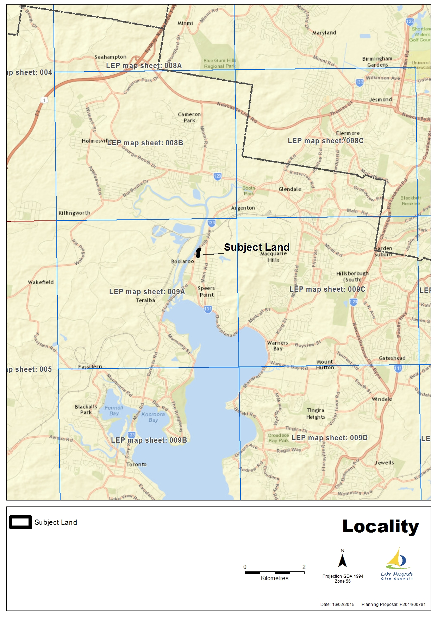

*Figure 2 – Aerial map*

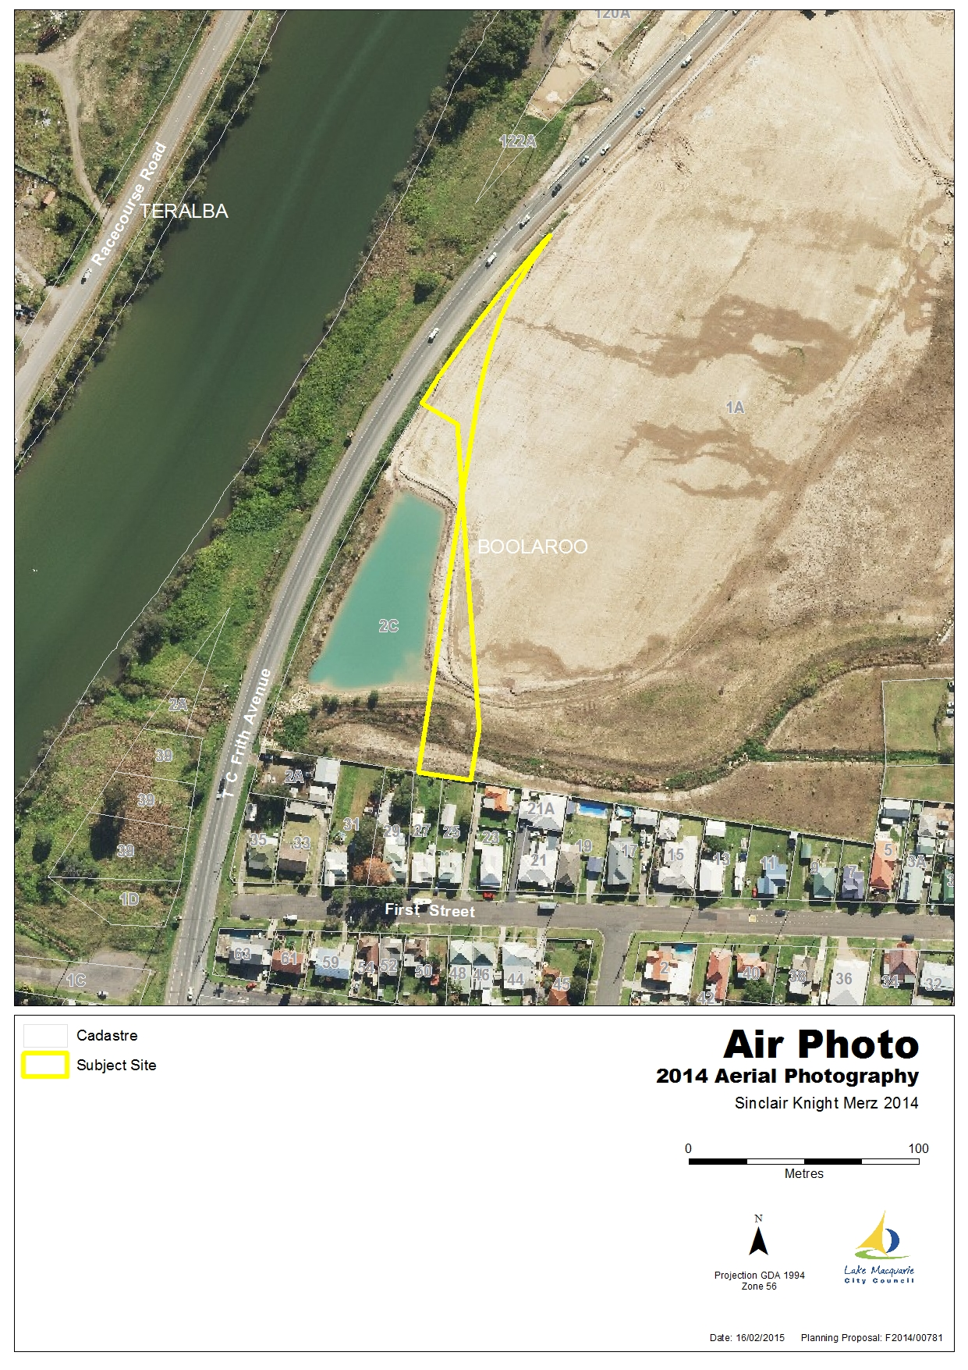

*Figure 3 – Existing zone under LMLEP 2014*

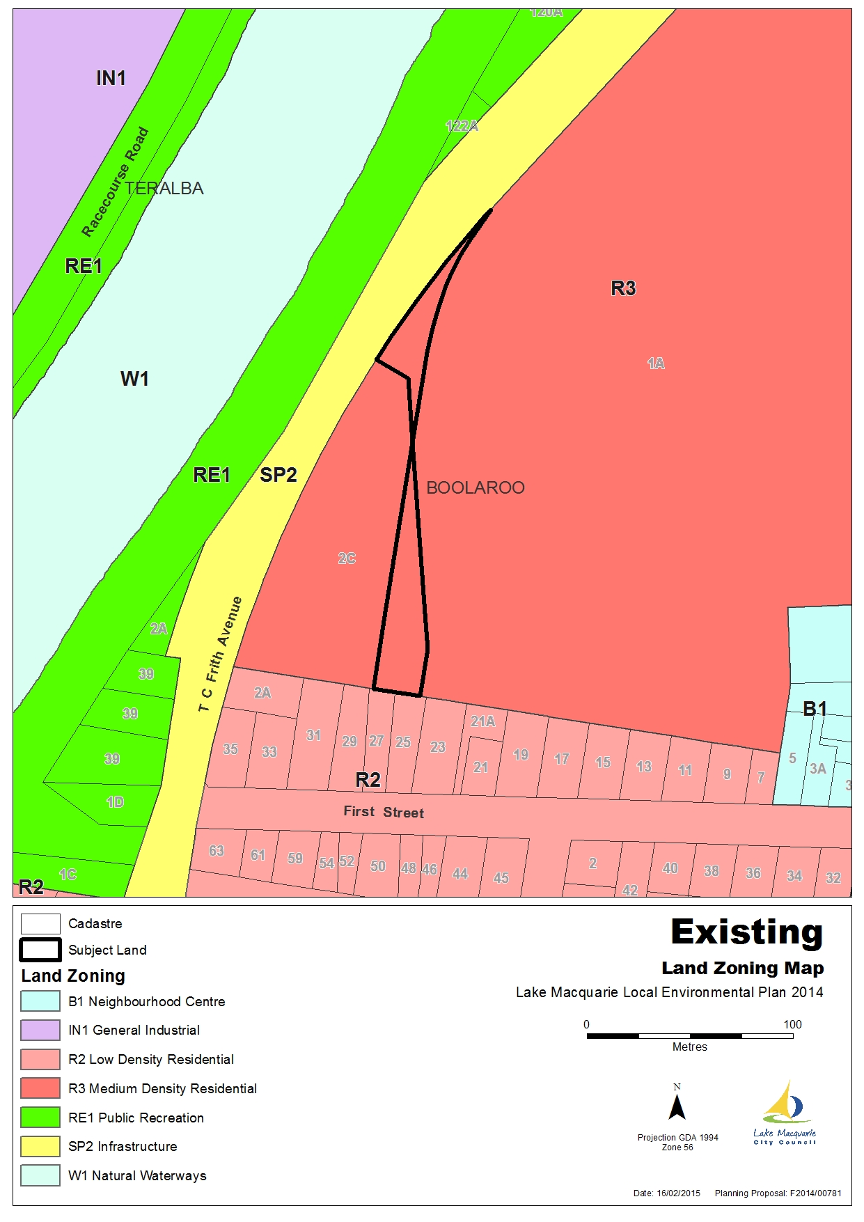

*Figure 4 – Draft Land Reclassification Map under LMLEP 2014*

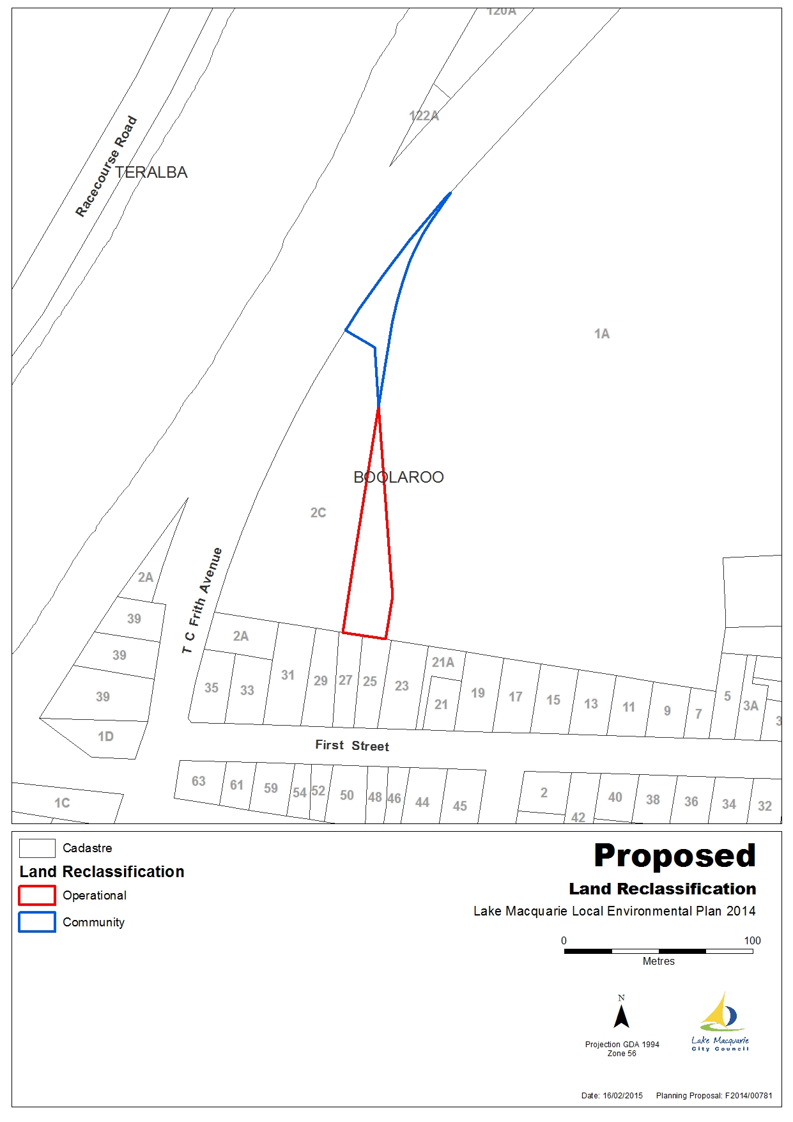

**ANNEX B – SEPP ASSESSMENT**

| *Planning Proposal’s Assessment against Applicable SEPPs* | | |
| --- | --- | --- |
| **SEPP** | **Applicable** | **Consistency** |
| State Environmental Planning Policy  No 19—Bushland in Urban Areas | N/A | The land and surrounding area relating to the Planning Proposal 2C T C Frith Avenue BOOLAROO (Lot 2 DP 1182441) is denude of all vegetation and ground cover. Accordingly this SEPP does not apply. |
| State Environmental Planning Policy  No 32-Urban Consolidation (Redevelopment of Urban Land) | N/A | The proposal only involves reclassification, the zoning and development controls shall remain the same and accordingly is considered to be consistent with the SEPP. |
| State Environmental Planning Policy  No 55 – Remediation of Land | Yes | The land and surrounding area relating to the Planning Proposal 2C T C Frith Avenue BOOLAROO (Lot 2 DP 1182441) and 1A Main Road (Lot 1 DP 1183441) have previously been identified as Contaminated Land. Remediation works have taken place, and a Site Audit Statement has now been issued by the NSW Environment Protection Authority stating that the land is now suitable for residential use. The land is zoned R3 Medium Density Residential and shall remain, the Planning Proposal only relates to the classification of the land. |
| State Environmental Planning Policy  No 71—Coastal Protection | Yes | The land relating to the Planning Proposal 2C T C Frith Avenue BOOLAROO (Lot 2 DP 1182441) is located within the Coastal zone. The Planning Proposal relates to a reclassification involving a boundary adjustment and will not affect the Matters for Consideration under clause 8 of the SEPP. Accordingly it is considered to be consistent with the SEPP. |
| State Environmental Planning Policy  (Housing for Seniors or People with a Disability) 2004 | N/A | The proposal only involves reclassification, the zoning and development controls shall remain the same and accordingly is considered to be consistent with the SEPP. |

**ANNEX C – MINISTERIAL DIRECTION ASSESSMENT**

| *Planning Proposal’s assessment against Ministerial Directions* | | |
| --- | --- | --- |
| **Ministerial Direction** | **Applicable** | **Consistency** |
| **1. Employment and Resources** | | |
| 1.1 Business and Industrial Zones | N/A | - |
| 1.2 Rural Zones | N/A | - |
| 1.3 Mining, Petroleum Production and Extractive Industries | N/A | - |
| 1.4 Oyster Aquaculture | N/A | - |
| 1.5 Rural Lands | N/A | - |
| **2. Environment and Heritage** | | |
| 2.1 Environment Protection Zones | N/A | - |
| 2.2 Coastal Protection | Yes | The proposed reclassification for the boundary adjustment will not impact upon the provisions of the NSW Coastal Policy, Coastal Design Guidelines 2003, or the NSW Coastline Management Manual. |
| 2.3 Heritage Conservation | N/A | - |
| 2.4 Recreation Vehicle Area | N/A | - |
| **3. Housing, Infrastructure and Urban Development** | | |
| 3.1 Residential zones | Yes | The reclassification of this planning proposal will allow for a boundary adjustment to facilitate future residential development in the subject area. It is considered to be of minor significance and that the planning proposal is consistent with the objectives of this ministerial direction. |
| 3.2 Caravan Parks and Manufactured Home Estates | N/A | **-** |
| 3.3 Home Occupations | N/A | **-** |
| 3.4 Integrating Land Use and Transport | Yes | It is considered that the proposed reclassification outlined within the planning proposal is of minor significance and consistent with the objectives of this ministerial direction. |
| 3.5 Development Near Licensed Aerodromes | N/A | **-** |
| 3.6 Shooting Ranges | N/A | **-** |
| **4. Hazard and Risk** | | |
| 4.1 Acid Sulfate Soils | Yes | The subject site is identified as Class 2 within the Lake Macquarie Acid Sulfate Soils Planning Map.  Any future development on this site would need to be aware of this constraint and address the requirements of Clause 7.1 of the LMLEP 2014. |
| 4.2 Mine Subsidence and Unstable Land | Yes | The subject site is identified within a Mine Subsidence District.  Consultation with the Mine Subsidence Board will be undertaken following receipt of the Gateway Determination to comply with the requirements of this direction. |
| 4.3 Flood Prone Land | N/A | The subject site is identified as Flood Prone land. This is not surprising as the subject land is a Drainage Reserve.  The reclassification is to enable a boundary adjustment and is considered to be of a minor significance.  Any future development on the new residential lot would need to be aware of this constraint and address the requirements of Clause 7.3 of the LMLEP 2014. |
| 4.4 Planning for Bushfire Protection | N/A | - |
| **5. Regional Planning** | | |
| 5.1 Implementation of Regional Strategies | Yes | The Lower Hunter Regional Strategy applies to the site. The strategy has been addressed within Part 3 – Section B (4) of the Planning Proposal. |
| 5.2 Sydney Drinking Water Catchments | N/A | **-** |
| 5.3 Farmland of State and Regional Significance on the NSW Far North Coast | N/A | **-** |
| 5.4 Commercial and Retail Development along the Pacific Highway, North Coast | N/A | **-** |
| 5.5 Development in the vicinity of Ellalong, Paxton and Millfield (Cessnock LGA) | N/A | **-** |
| 5.6 Sydney to Canberra Corridor | N/A | **-** |
| 5.7 Central Coast | N/A | **-** |
| 5.8 Second Sydney Airport: Badgerys Creek | N/A | **-** |
| 5.9 North West Rail Link Corridor Strategy | N/A | **-** |
| **6. Local Plan Making** | | |
| 6.1 Approval and Referral Requirements | Yes | It is considered that the planning proposal is consistent with the objectives of this ministerial direction. |
| 6.2 Reserving Land for Public Purposes | N/A | The site the subject of the Planning Proposal, is dedicated as Drainage Reserve. |
| 6.3 Site Specific Provisions | N/A | The reclassification included within the Planning Proposal will not change the zone of the site or the land surrounding the subject site. No site specific provisions or development standards in addition to those already contained within the LEP will be applied. |
| **7. Metropolitan Planning** | | |
| 7.1 Implementation of the Metropolitan Plan for Sydney 2036 | N/A | - |

**ANNEX D – COUNCIL RESOLUTIONS**

Background:

In April 2014, Council was approached by Environmental Property Services Pty Ltd (EPS) acting for the current owner of land (1A Main Road Boolaroo), which adjoins the subject land (2C T C Frith Avenue), owned by Council.

EPS had prepared a subdivision plan for the subdivision of their adjoining land, being Lot 1 DP 1183441 with the plan showing a road and a lot over the Council-owned drainage reserve (Lot 2 DP 1183441).  Discussions were held and it was agreed that a boundary adjustment would be undertaken to adjust the boundary of the Drainage Reserve, wherein a land exchange would be facilitated. The boundary adjustment would enable the Developer to rationalise the road configuration enabling the road and housing lot, in exchange Council would receive additional land along the T C Frith Avenue frontage for incorporation into the Drainage Reserve.  Given that the land was originally dedicated to Council by the applicant at no cost to Council, this course of action seemed reasonable. Council signed the Development Application (DA) to allow the DA to be lodged over its land.  The DA was approved by Council (under delegation) on 2 September 2014 (DA/442/2014).

It has now come to Council’s attention that the boundary adjustment cannot be facilitated as the Drainage Reserve (Lot 2 DP 1183441) is classified as Community Land. Pursuant to section 45 of the LG Act 1993 Council has no power to sell, exchange or otherwise dispose of community land and accordingly the land needs to be reclassified to Operational Land.  The land was classified as Community at the time of dedication in March 2013 as it was intended to be used as a drainage reserve. This use still remains with the proposed boundary realignment. In order to allow the development to continue in its current form, that part of the drainage reserve to be exchanged, as shown on Attachment 1, at 2C TC Frith Avenue Boolaroo (Lot 2 DP 1183441) needs to be reclassified as Operational Land.

Proposal:

Council has provided DA approval for a land subdivision on the adjoining land (Lot 1 DP 1183441) and a boundary adjustment is required in respect to the existing Drainage Reserve (Lot 2 DP 1183441). The boundary adjustment will enable a land exchange, a better layout of the adjoining subdivision and works to be undertaken to the Drainage Reserve as part of the land subdivision. The Drainage Reserve is classified Community Land and before the land exchange can take place, the section of land to be exchanged needs to be reclassified to Operational Land.

Approval is being sought for reclassification of the land from Community Land to Operational Land to facilitate a boundary adjustment.

Consultation:

No objections have been raised to the proposed reclassification from the relevant Council officers:

* Principal Development Engineer
* Coordinator – Social & Community Planning
* Ecosystem Enhancement Coordinator
* Coordinator – Recreation & Land Planning
* Environmental Planner
* Senior Development Planner
* Senior Strategic Landuse Planner
* Development Planner – Flora & Fauna
* Chief Subdivision Engineer

Implications:

Policy Implications:

The proposals are generally consistent with relevant State Environmental Planning Policies; section 117(2) Ministerial Directions and the Lower Hunter Regional Plan. No significant issues or areas of concern have been identified.

Environmental Implications:

The site and surrounding land has previously been identified as significantly contaminated land and remediation works have taken place. A Site Audit Statement has now been issued by the NSW Environment Protection Authority stating that the land is now suitable for residential use.

Due to the remediation works the land is clear of all vegetation and ground cover. Lot 2 DP 1183441 (2C T C Frith Avenue Boolaroo) contains a drainage basin which currently contains water.

Due to the small-scale nature of the proposed reclassification, Council officers consider it unnecessary to prepare an environmental study under section 57 of the EP&A Act 1979.

Social Implications:

No social impacts are envisaged to result from the change in classification given:

* The site is vacant and is currently being used as a drainage reserve, which will continue;
* The proposed land exchange will enable a better layout of the adjoining land subdivision; and
* The proposed boundary adjustment will enable a land exchange giving the community approximately the same amount of open space within the locality.

Infrastructure Asset Implications:

The reclassification and subsequent land exchange will negate the requirement for further maintenance of that land. The land is currently vacant and contains a drainage basin which is in a current maintenance schedule. Eventually maintenance responsibility for the drainage infrastructure will pass to Council.

Financial Implications:

The land was originally dedicated to Council by the applicant at no cost to Council. During the Development Application stage, it was agreed that a boundary adjustment would be undertaken to adjust the boundary of the Drainage Reserve, wherein a land exchange would be facilitated.

The administrative costs of the reclassification will be shared (50%) with the adjoining owner.

Risk and Insurance Implications:

If Council proceeds with the reclassification and subsequent land exchange then the subdivision on the adjoining land can take place as approved, and there would be no risks to Council.

The level of risk associated with the preparation of a Planning Proposal is minimised by following due process as established by the Environmental Planning & Assessment Act 1979, the Local Government Act 1993, the Environmental Planning and Assessment Regulation 2000, and Council’s Procedure Document, Amending LMLEP to Reclassify Land. This action is covered by Council’s professional indemnity insurance as a standard activity.

If the reclassification does not proceed then the land exchange would not be possible. The adjoining owner would then need to revise their subdivision plan, requiring a new Development Application to be submitted with additional costs and time associated with this process.

Options:

1. To proceed as recommended and commence preparation of a Planning Proposal. This option is favoured as it will enable the boundary adjustment and land exchange to occur, and will result in a better layout of the adjoining subdivision.
2. To do nothing. This option is not favoured as this may expose Council to risk. the adjoining owner would then need to revise their subdivision plan, requiring a new Development Application to be submitted with additional costs and time associated with this process.

Conclusion:

It is considered appropriate to reclassify the existing Drainage Reserve located at 2C T C Frith Avenue Boolaroo (Lot 2 DP 1183441) to Operational Land to enable a boundary adjustment for a land exchange to occur. This will result in a better layout of the adjoining residential subdivision at 1A Main Road Boolaroo (Lot 1 DP 1183441).

*Do not delete this line*

Manager Property & Business Development – Kate Cramp

|  |  |
| --- | --- |
| Council Minute Item  Action | |
| City Strategy Committee | 9/02/2015 |

|  |  |
| --- | --- |
| **TRIM Ref:** | D07275469 |
| **Subject:** | Reclassification Request Amendment - Lake Macquarie Local Environmental Plan 2014 - Boolaroo |
| **Date to be Completed by:** | 23/02/2015 |

|  |
| --- |
| *Instructions to User* |
| This TRIM action is assigned to you to complete. Record all actions taken in TRIM using InfoCouncil’s process to add a note, and then complete the TRIM action via InfoCouncil. |

|  |
| --- |
| **Council Decision:** |

12

Moved. Cr. W Harrison

Seconded. Cr. Langford

A. Council authorises the commencement of action to prepare a Planning Proposal, as follows:

i) Reclassification of part of Lot 2 DP 1183441 (2C T C Frith Avenue Boolaroo) from Community Land to Operational Land for the purpose of a boundary adjustment as indicated on Attachment 1;

ii) Classification of part of Lot 1 DP 1183441 (1A Main Road Boolaroo) to Community Land for the purpose of a boundary adjustment.

B. Council authorises the notification of Council’s resolution, and submits a Planning Proposal pursuant to section 55 of the Environmental Planning and Assessment Act 1979 (EP&A Act 1979), to the Department of Planning & Environment (DoPE).

C. Upon receipt of DoPE’s Gateway Determination under section 56 of the EP&A Act 1979, and in accordance with DoPE’s direction, Council authorises the exhibition of the Planning Proposal.

D Council authorises notification of the public hearing, in a local newspaper, in accordance with section 29 of the Local Government Act 1993 (LG Act 1993).

E If no submissions are received in respect to C and D above, and no variations are proposed, then the Planning Proposal shall be submitted to the Minister in accordance with section 59 of the Environmental Planning and Assessment Act 1979.

F If submissions are received in respect to C and D above, then a further report to Council shall be submitted to consider such submissions.

In accordance with Section 375A of the Local Government Act 1993 a division took place.

|  |  |
| --- | --- |
| For the Motion | Against the Motion |
| Cr. Fraser |  |
| Cr. Johnston |  |
| Cr. Coghlan |  |
| Cr. Adamthwaite |  |
| Cr. Denton |  |
| Cr. Griffith |  |
| Cr. Langford |  |
| Cr. Pauling |  |
| Cr. Paxinos |  |
| Cr. W Harrison |  |
| Cr. J Harrison |  |
| Cr. Dawson |  |
| (carried) |  |

(Carried)

|  |
| --- |
| *End* |

*The minutes of City Strategy Committee on 9/02/2015 is located in TRIM folder titled ‘GOVERNANCE - COUNCIL MEETINGS - Minutes and Agenda - Council Agendas & Minutes - PDF Version’*

**ANNEX E – OWNERS CONSENT**

